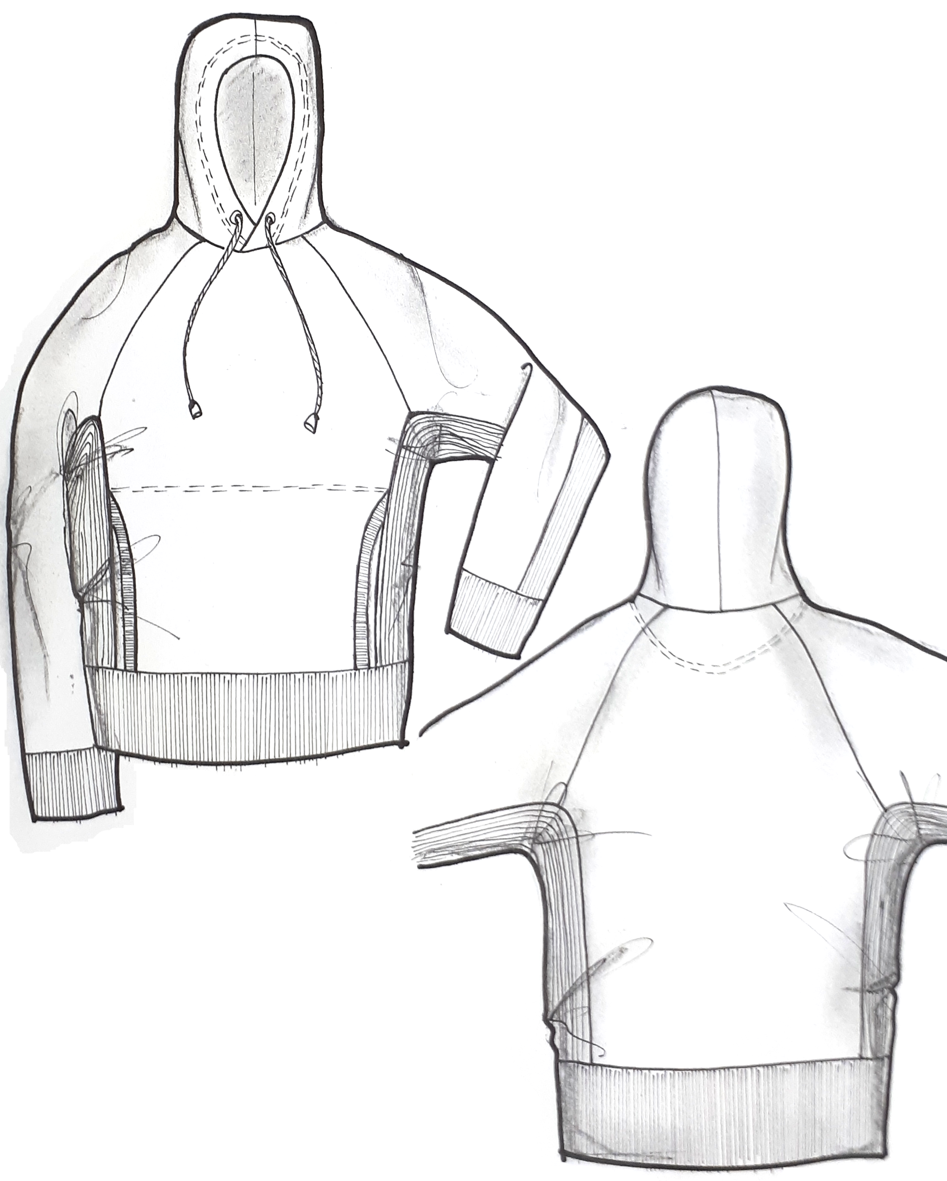

Hooded Sweatshirt

Workshop